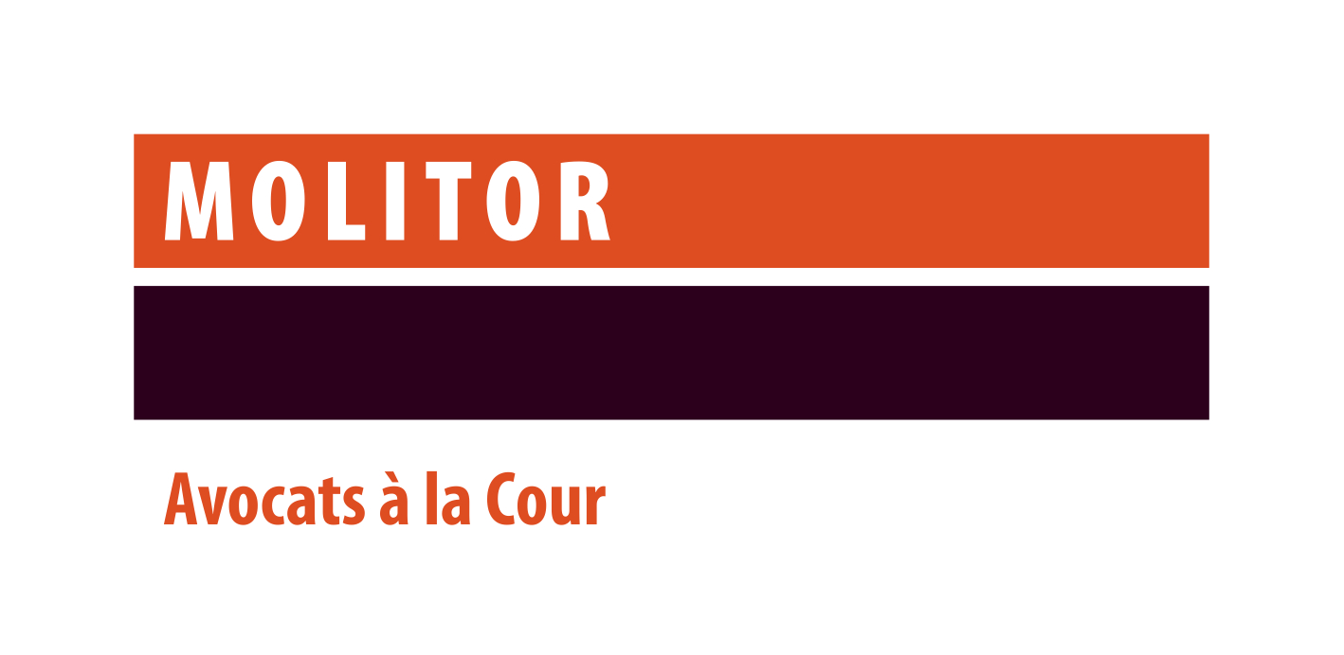

We seek to further strengthen our team with a
Lawyer for our Corporate and M&A practice
Contact: Sophie Icher - sophie.icher@molitorlegal.lu

Your mission
- Assist, advise and represent our domestic and international clients on corporate and M&A transactions (including asset/ share acquisitions, investments, shareholders’ agreements, tax-driven cross-border restructuring transactions, etc.) and corporate finance transactions;
- Be part of a team and work closely with the Corporate M&A partner, counsel and associates, as well as interact with members of other practice group in cross practices matters;
- Participate meetings and conference calls for international clients;
- Follow-up on legal updates on Corporate and M&A and corporate finance matters.

Your profile
- At least 3 years of experience in Corporate and M&A (including due diligence, asset and share deals, corporate transactions and advice) and possibly in corporate finance practice areas in Luxembourg law firms, advising and representing clients (transactional and advisory) and drafting and negotiating transactional documents;
- A Master degree in law (or similar degree), an LL.M. from a reputable university in the UK or USA would be considered as an advantage but not a must;
- You are admitted to the Luxembourg bar or another European bar;
- Excellent legal and analytical skills;
- An excellent command (written and spoken) of English and French;
- Ability to work in teams as well as autonomously;
- Client oriented.

Our values:

We have a strong focus on how we recruit, train and reward our staff and always ensure that they are fully aligned with our work culture built around our four core values:
- Service Excellence - We seek to exceed our clients’ expectations, through impeccable quality advice and deliverables.
- Integrity & Trust - We ‘walk the talk’ – Being widely trusted by all our counterparts is essential to us.
- Teamwork – We place team goals above individual goals
- Approachability – Building rapport with all our counterparts is a key priority for us.

About the firm:

We are a top independent law firm based in Luxembourg with a wide international network. Local and international clients rely on us for our recognised expertise in legal matters and disputes involving Luxembourg law. We pride ourselves in being a multidisciplinary firm serving all major sectors of the economy.

